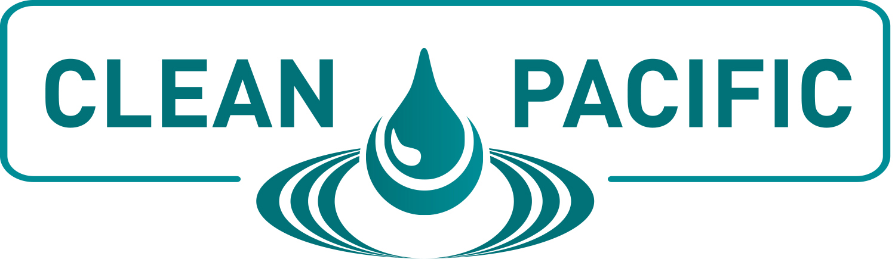

SAMPLE LETTER TO MANAGEMENT

I would like to register to CLEAN PACIFIC 2021. The conference will be held June 28-30 at the Hyatt Regency Lake Washington at Seattle’s Southport in Renton, WA.

CLEAN PACIFIC offers a variety of sessions and workshops as well as 50+ exhibiting companies targeting spill prevention, response and remediation in the Western United States and Canada. I will be able to attend a number of sessions that directly apply to my ongoing projects at this organization and visit with numerous companies who can provide solutions catered to our unique needs.

The conference sessions are led by well-known industry experts and will offer tips & strategies that I can implement upon my return. A few sessions that I am particularly interested in include <insert session titles.> I would like to attend these because I feel I will gain <insert learning objectives> and be able to implement the findings in <insert projects or departments that will benefit.>

This conference will enable me to build relationships with various operators, responders, regulators, local indigenous people, equipment providers, and environmental groups and learn from their experiences in spill prevention, response and remediation. The information I take away from this conference, as well as the contacts I make, will be invaluable for future endeavors at our company.

The CLEAN PACIFIC exhibit hall will feature more than 50 leading companies who can provide products and solutions to improve spill prevention, response and remediation efforts. I will have the opportunity to meet with many of these companies, virtually eliminating the time and cost of separate future trips to each company.

By registering early, I can save on registration by receiving a discounted rate. Additionally, if multiple people from the company register at the same time, we can receive even deeper discounts. I am asking for funding for the conference fee, travel costs, food and lodging.

CLEAN PACIFIC has arranged for hotel and airfare discounts. In addition, the full conference registration includes two days of breakfast, lunch and a networking reception.

I feel that attending CLEAN PACIFIC is a valuable experience that would greatly benefit my performance at this organization. I will be able to bring home all conference materials, allowing me to share with others in the office and possibly train them if needed.
Thank you for considering this proposal. Please let me know if there is any additional information I can provide to help make your decision.

